**Anodizing SOP V2.0**

This SOP will guide you through the process of anodizing TITANIUM PRODUCTS ONLY. If you are not sure if what you want to anodize is 100% TITANIUM, STOP AND FIND OUT. Please follow all safety and PPE (personal protective equipment) recommendations.

You are expected to clean up after each and every use. You are expected to help maintain the station if you ever use it.

**Tools you’ll need:**

1. Safety glasses
2. Latex or nitrile gloves
3. Small fan
4. Distilled water
5. Hot plate
6. Power supply
7. Digital scale
8. Anodizing wand
9. Plastic strainer
10. Spool of titanium / niobium wire for making hooks for dipping
11. Misc tweezers and/or hemostats
12. Shop rags
13. Paper towels
14. Titanium Etch bath (safer hydrofluoric acid substitute)
15. Anodizing solution (Borax / trisodium phosphate / DI water solution)
16. Pre cleaning solution (simple green)
17. Ultra-sonic cleaner

See photos for reference.

**Layout**

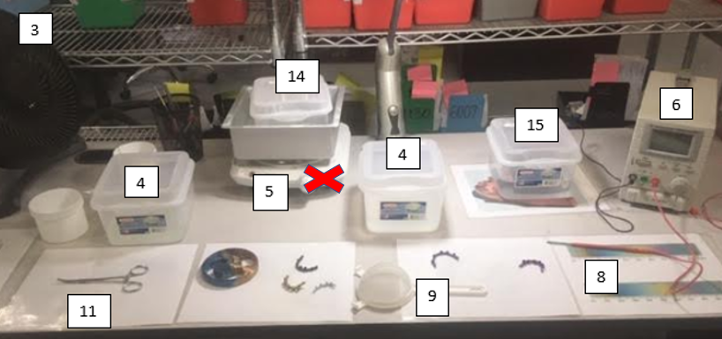

**Gloves and safety glasses should be worn throughout the process both for contamination prevention and safety.**

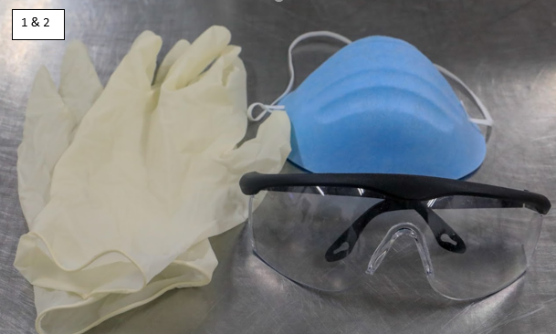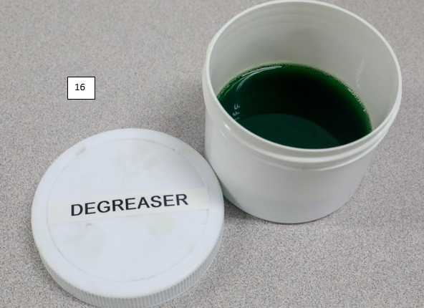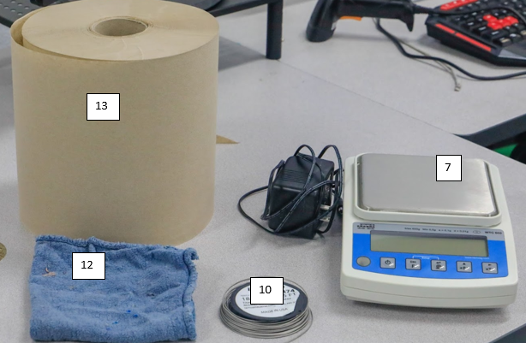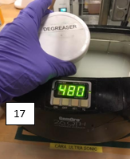

**What NOT to do:**

**Do NOT** put any other material in the chemical baths or risk unintended chemical reactions.

(See SDS located at the station for more info on etch bath)

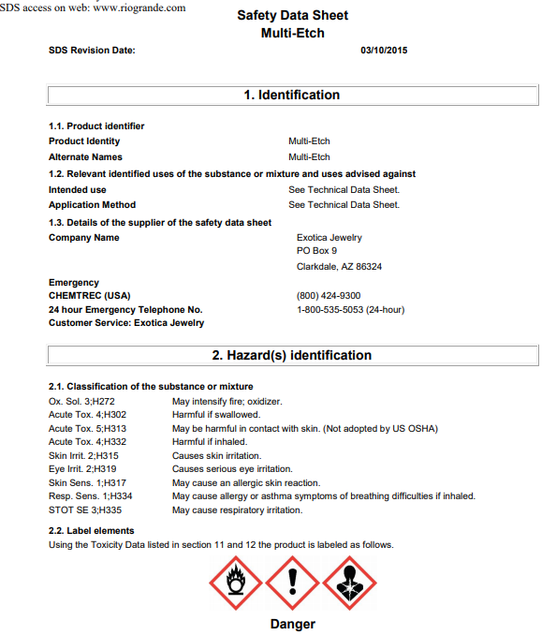

Complete SDS will be at station at all times.

**Do NOT** heat the Etch solution without its double boiler setup.

**Do NOT** heat the Etch solution

**Do NOT** use station without a fan blowing toward the Etch bath (**not towards you**).

**Do NOT** leave the power supply on prior to putting down the wand or lead.

**Do NOT** use anything other than Nobium or plastic tools in etch bath.

**Never** close the circuit (positive red to negative black).

**Never** mix patient oders.

**Solutions list**

**Multi Etch** – purchased and premixed

Lifespan – until it no longer removes anodized color or six months (11 years if dry)

Replacement – add DI water if too thick from evaporation

Disposal – Dispose of contents / container in accordance with local / regional / national / international regulations.

**Simple Green** – purchased premixed

Lifespan – 5 years

Replacement – when discolored / dirty

Disposal – Dispose of contents / container in accordance with local / regional / national / international regulations.

**Anodizing solution** – 5MG of trisodium phosphate (Borax) mixed with 1L of DI water

Lifespan – 1 week

Replacement – when discolored with floating sludge / dirty

Disposal – Dispose of contents / container in accordance with local / regional / national / international regulations.

**Best practices**

All abutments from the same patient should be done at the same time to keep consistent color.

Segregate abutments by case as not to mix up patient orders.

Be sure all tools and station is clean prior to use. Change DI water and anodizing solution if necessary.

Step 1. Remove sharp edges or have them removed if any.  Place Ti abutments in degreasing container filled with simply green.  Place container in ultra-sonic for 180 seconds with heat activated (TC button).  Rinse in DI water upon completion.

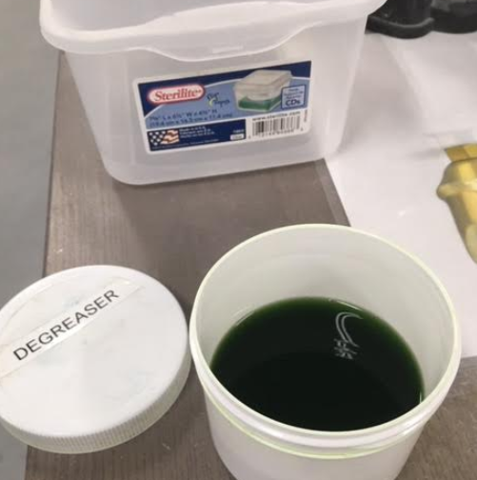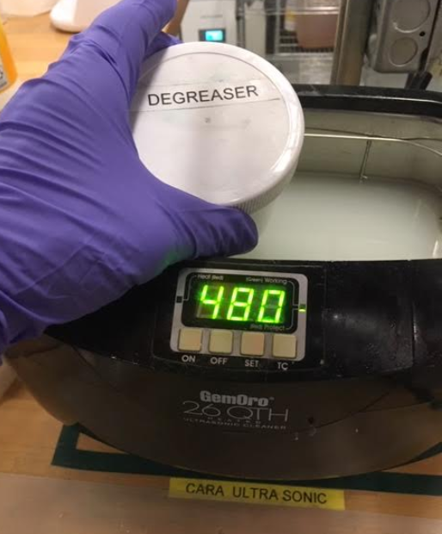

Step 2. Using Ti hook or holder, dip the Ti bar or abutments in the cool Etch bath for 35 to 55 seconds.  Rinse in DI water upon completion. (******PPE and Fan should be on for safety prior to this point*******)

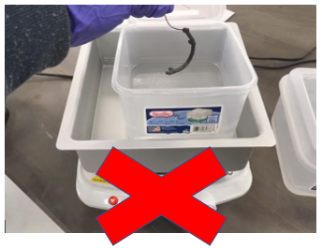

Step 3. . Place item(s) to be anodized in plastic holder / compartment holder and submerge them in the anodizing bath.  Using the anodizing wand connected to the power supply set at just below the voltage for the desired color, stir the item(s) being sure to touch each one while submerged.  Bring the voltage up to your target voltage in 5V to 10 V increments and watch for color change.

Upon reaching your color, remove the item(s) from the bath. Turn off the power supply and rinse the item(s) in DI water.

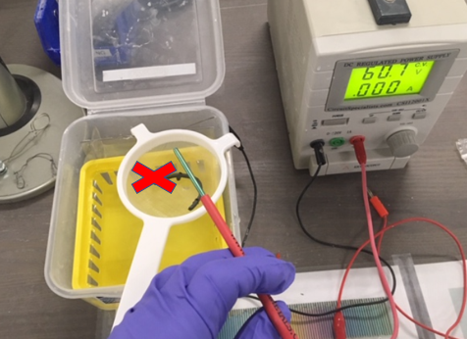

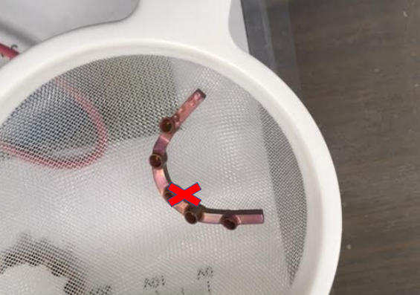

Step 4.  Dry and inspect for color.  If item is under colored, you may go back to step 3. If item is over colored, you may place the parts back in the heated etch to remove color and try anodizing again.

Step 5. Be sure Etch bath hot plate is turned off after use. Verify power supply is turned off after use. Wipe down the station and clean off all tools for future use. Close lids on Etch bath and Anodizing bath.

In conclusion, the steps to excellence are as follows:

* Degrease with simple green
* Rinse in DI water
* 35 - 55 seconds in Etch bath
* Rinse in DI water
* Turn to color in anodizing bath
* Rinse in DI water
* Repeat steps based on color attained
* Don’t heat etch
* Use holders / stirrers that won’t contaminate the baths (e.g., plastic niobium, titanium)
* Keep everything CLEAN
* WORK SAFE ***and FOLLOW THE PROCEDURE***